 The Summit at Autumn Hills (SAHA)
New Neighbor Guide

Welcome to the neighborhood! We’ve prepared this guide to help make your move into our community as smooth as possible. Livingston Mountain provides rare opportunities to commune with nature yet is close enough to the convenience of retail facilities and the Portland International Airport. We are sure you will enjoy living here!

History
Our mountain has an interesting history. In 1902, the area was part of the infamous Yacolt Burn. Although the fire actually started in Oregon, it spread across to the Washington side from windblown embers. The many giant tree stumps and fallen logs throughout the community are the remains of this devastating fire. The large trees you see now are the second growth.
Starting in 1937, this area was inhabited by “the goat lady”, Gladys Fulton. She owned 372 acres and raised…goats! She had no electricity, but if her car battery was charged, she could communicate via her CB radio. She faced down rustlers and coyotes with her trusty shotgun. She was quoted saying, “Up here, I hear frogs. Down there, you hear motors. Up here, I smell fresh air, and down there, you smell gasoline.” Most of us feel the same.
Community Overview
Bordering our neighborhood of 95 lots is Logging Road 1000 (L-1000), which connects to L-1200. L-1200 drops into the Brush Prairie area. This road is an alternative exit for us and is also used by logging trucks and sports enthusiasts (dirt bikes, quads, bicycles, joggers). We recommend taking time to explore this road. Unfortunately, we also experience the occasional illegal fire arms shooting. For more information on reporting this dangerous activity, contact our Community Awareness Committee.

SAHA is divided into five phases. The community website has a diagram reflecting the break down. Phase 5 is across the L-1000 road just past gate 2. All mailboxes are located outside gate 1, the main entrance, as are newspaper delivery boxes. Although there are cameras at our gates, they are currently not working and are in place to serve as a deterrent.

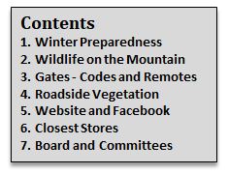
We hope this guide helps! Please don’t hesitate to reach out to any SAHA Board member with any question.

1. Winter Preparedness
Here on the mountain, we are at 1500 to 2000 feet elevation. So, we are exposed to weather unlike that experienced in Vancouver and Portland. It is not unusual for us to have two to four feet of snow. Ensuring you are ready for it is key. Our Roads Committee maintains our roads but in between plowing, the roads can be icy, especially Spud Mountain Rd. Be cautious, and use common sense. Here are some tips to help:

- Make sure your propane tank has plenty of gas. In adverse weather, propane providers are unable to make it up to our neighborhood.
- Consider purchasing a generator. Although our utilities are underground, frozen tree limbs can down power lines outside of our community. A day or two…or three, with no power in the middle of winter can be chilly.
- Four wheel drive or AWD vehicles, although no help on ice or freezing fog can be helpful. Studded tires are also an option. Use caution driving down the mountain in inclement weather.
- Keep candles and flash lights handy in case of a loss of power.
2. Wildlife on the Mountain
We are surrounded by wildlife, which is much of the joy of living here. We have black bear, deer, bobcats, mountain lions, coyotes, weasels and more.
If you have small dogs, we suggest proper supervision at all times when they are let outside. Cats allowed outside are not safe.
Please exercise caution when driving in our community. Many residents own horses and ride them on the roads. We enjoy walking our roads to take in the view, so you’ll often see strollers and young children, along with pets. Our local deer call this home, also, and often see the road as theirs. Our 25 mph speed limit is intended to keep everyone safe.
3. Gates – Codes and Remotes
As a gated community, we have multiple means of entry. The first step is to contact Mike Bell at <bellmjb@gmail.com>. He manages the software for our gates as well as provides access codes. Should you need short term access for contractors, Mike will provide you temporary codes so that your personal code remains uncompromised. He will also add your contact information to the kiosk so visitors can call you for gate access. You must have a phone number with a (360) area code in order to be compatible with our system.
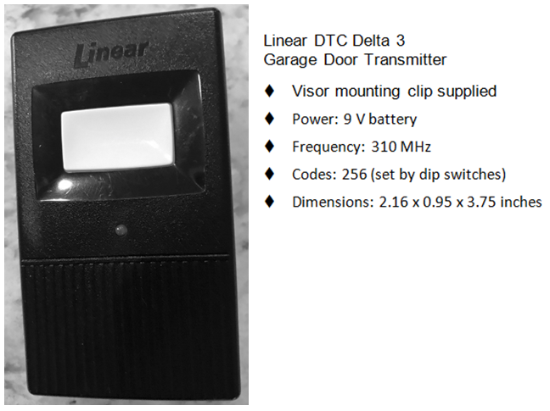
New neighbors are issued two remote devices per household. Hopefully, the former residents will leave their remote devices for you. Below is the information you’ll need to program your vehicle if it is so equipped. Additional remotes can be ordered from various suppliers (see below), including Amazon. It is very important that the MHz and the switch numbers are followed as any other clicker set up will not work.
Once your phone number is in the kiosk directory, guests can scroll to your name, and you will receive a call from the kiosk. Press “9”, and the gates will open.

If someone needs help putting the dipswitch codes in their clickers, call George Kinsey (360-833-8130).
As of July 30, 2017, George Kinsey has 18 remotes for $10.95 each. If you wish to order one yourself, the best vender is DoorOpenersandMore.com (1-888-830-6006).
4. Roadside Vegetation and Views
Ensuring SAHA properties are in compliance before the snow flies is of utmost importance for safety. We all need to ensure that emergency vehicles have easy access to each and every home as well as to minimize branches that may break and block a road during a snow storm. In the past, we have had snow accumulations approaching 4 feet. Snow in this area tends to be very heavy, resulting in a lot of vegetation falling on the roads. Ice storms just exacerbate the breaking of branches/trees.
Trees and overhanging branches are to be kept trimmed back 8 feet from the edge of all roads and up to a height of 12 feet above the road edge (East County Fire & Rescue now recommends clearing to a height of 14 feet). It is the Owners’ responsibility to maintain their property throughout the year according to the ACGs requirements. As per our CC&Rs, this is a view community. Each home owner is responsible for potential view blockage complaints received from fellow home owners. Home owners are asked to do their best to work out the situation with their neighbor before filing a complaint with the Board of Directors.
5. Website and Facebook
Our community has its own website at http://summitautumnhills.org. The secretary of the Association will provide you a user name and password. On this website, Board of Director minutes, agendas, committee reports, resident directory and a variety of other information are available. We will do our best to contact you if we have a current email address, but please reach out to Michael Marcum at <marcummichael@hotmail.com> if you are not contacted in a timely fashion.
We also have our own private Facebook group. Our group is The Summit at Autumn Hills. Once you request membership, a member of the Board will authorize your access. Our FB group is very active and a great way to keep in touch with community events, wildlife sightings, board meetings and general community information.
- Closest Stores
- For the quick items, Fern Prairie Market is 5.4 miles away. The address is 1817 NE 267th Ave, Camas, WA 98607
- A Safeway grocery store is at 6700 NE 162nd Ave, Suite 500, Vancouver, WA 98682
- Costco and other stores are just down the mountain off SE 192nd Ave
- SAHA Board and Committees
Our community is managed by an all-volunteer Board of Directors. Vacant positions are up for election during the annual meeting held in March of each year. Our By-laws contain details regarding each position’s responsibilities. We also have a number of all-volunteer committees. The Board and the committees are always looking for new members, so feel free to reach out to any Board member or a committee chair for more information.


